Financial Model FM-PRO 3.4

Template User Manual

Professional Financial Modeling Tool

ITILLECT 2022

Table of Contents
Purpose 3
Functional Description 4
For Developers 5
Agreement 5
Technical Requirements 5
Template Structure 6
Work with the Tool 7
Navigation 8
Quick Building of a Financial Plan. 9
Build a Financial Model 11
Project Organization Planning 11
Source Data 12
Indexing of Results 12
Sales Planning. 13
Multicurrency Calculations 16
Currency Rate 17
Cost Planning. 19
Variable Costs 19
Fixed Costs 21
Capital Investment 22
Expenditure Allocation Timing. 23
Maintenance capex 25
Employee 26
Financing 27
Taxes. 29
Reports and Analytics 32
Making Forecasts 40
Technical Features of Working with the Tool 42
Adding lines to the template 42

Purpose
Building a financial model and assessing the investment attractiveness of project (company).
The FM-PRO 3.1 financial modeling template is a universal professional tool for creating a plan and receiving reports on the financial activity of a project (company). The template allows to:
- create financial plans for the implementation of projects (companies) of diverse complexity with the aim of building a business plan,
- create a financial calculation of planning and analyzing of the existing company (project) activities,
- carry out a graphical analysis of the results, use the data in other documents and reports,
- do work collectively, forward calculations to colleagues for studying, present to investors.

Functional Description
The simplicity and flexibility of using the source data, the speed of creating basic calculations. When the template is filled with the source data in accordance with the methodology, you will need from 15 to 30 minutes to obtain basic calculations.
Multicurrency support. The template allows to make calculations in ten different currencies at once, to assign your own currency and the rate of settlement operations.
For each revenue or expenditure item, you can establish the currency of account and specify the amount. The FM will automatically recalculate the entered value in the main currency of account.
Simplicity and flexibility of planning. The tool allows to execute a complex financial plan of the project implementation. To set source data and flexibly manipulate the calendar flow over the entire planning horizon, to link sales and costs, to determine the share ratio of cost items, to specify local validity periods.
Scalability. The template is dynamically scalable and has no limits on the amount of input source information. It is you who decide how much and what information to use.
Analytics and analysis. The template allows to define your own catalog of products and services, product groups, set analytical groups for further analysis for all types of income and expenses of the project.
Usability of source data input. The template allows to structure and collect your source data in one place. Built-in tools for rapid planning, such as "periodicity", "organization of connections between objects" significantly save time.
Open source. The template has an open architecture. This will allow to independently develop the product, generate calculations, create your own calculations, integrate with external data sources.
Cross-platform. The template was developed using standard Excel formulas common for MS Excel 2010 – 2016 (365), does not contain scripts, external add-ins, or Visual Basic for Applications programming models, and this allows using the tool equally effectively on MAC and PC platforms.

For Developers
Open source. For specialists, we offer the possibility to modify the template code. The tool uses only the basic data handling logic.
Usability of intermediate calculations. The template collects intermediate calculations of the first and second levels in a simple, understandable form for further independent use and generation of own calculations and reports.

Agreement
This agreement describes the relationship between the Developer and the Consumer (between Itillect LLC and the Buyer) in case of introduction of modifications in the template.
- We strongly recommend not to change the calculations, logic, relationships forming the integrity of the generic template, if the current user qualification is lower than "experienced operator".
- In accordance with this Agreement, the Buyer shall have an opportunity to:
  - independently change the data in MS Excel source data entry forms as they see fit, add sheets to the template, use current calculations to build additional calculations,
  - include own calculations in the template, change the existing data processing logic.
- The Developer does not provide technical support in terms of training, explanations regarding the mathematical and logical solutions used in the template.
- The Developer disclaims the responsibility of technical support for the modified template.
- Each template file has a unique identifier, and is linked to the Buyer. By purchasing the financial model, you agree to the following terms and conditions:
• Do NOT make the template file freely available to the public;
• Do NOT resell the template file to third parties on a commercial basis;

Technical Requirements
parameter | minimum | recommended
PC configuration | CPU at least i5, not less than 4GB. | CPU i7, RAM 8 GB and more.
ОS | Windows 7, 8  MAC OS 10.9 Mavericks or higher | Windows 10  MAC OS 10.9 Mavericks or higher
Excel | MS Excel 2010 – 2019(365) (local lang)  MS Excel 2011-2015 for MAC (local lang)

Template Structure
The template is created as a normal standalone MS Excel file, without using macros and add-ins. The basis for data entry and generation of calculations are regular Excel sheets.
The sheets contain:
- related fields (cells) of data entry,
- fields with calculating formulas,
- fields with drop-down lists.
The data entry fields are green (1). Fields containing formulas and relationships have a background of yellow color (2), blue fields contain drop-down lists (3).
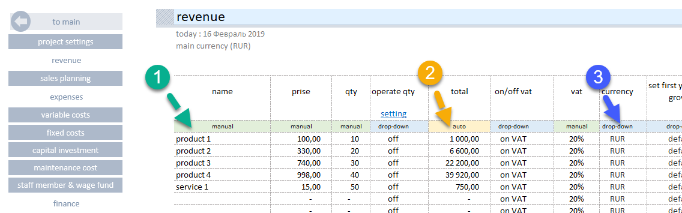
The template consists of:
source data entry forms and navigation linking them.
- The color of source data entry sheets is light green.

- The color of sheets containing tables, reports and diagrams is green.

Work with the Tool
The essence of filling the template with data is sequential input of information in the input forms. In the process of entering the initial data, the template automatically calculates totals and builds reports and graphs based on them.
Fig. Structure

Plan the financing

Navigation
The template has a simple navigation structure.
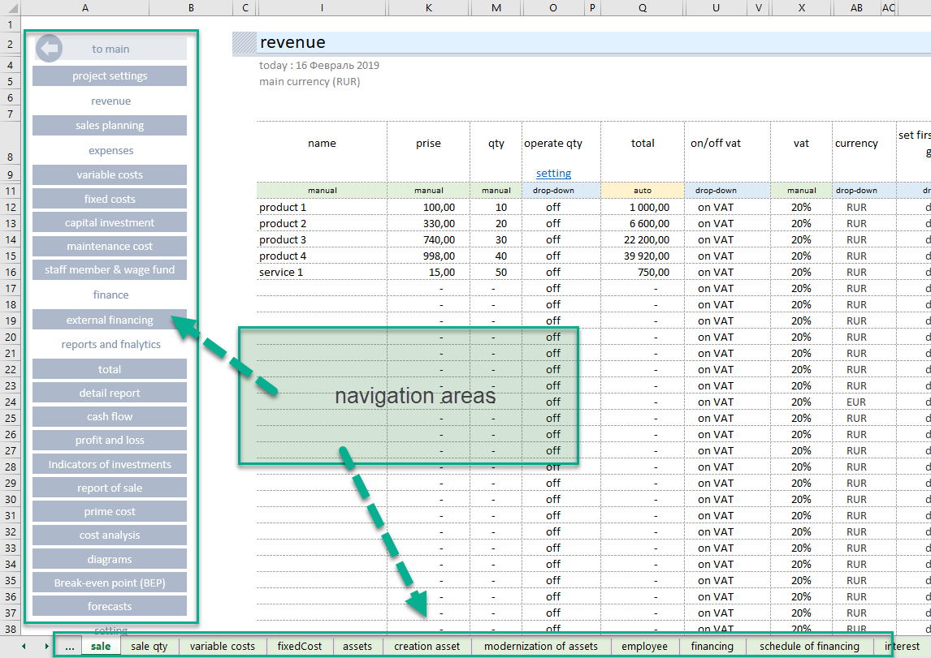
Each sheet contains an independent navigation allowing to quickly move between input forms and calculations.
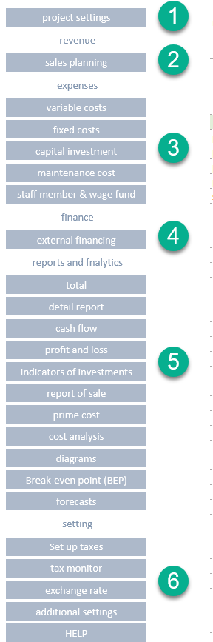
All sections are grouped by purpose:
  - Customize the environment.
  - Plan sales.
  - Plan costs.
  - Plan the financing.
  - Reports.
  - Settings.

It is convenient to navigate through sections using the built-in navigation or regular Excel sheets.

Quick Building of a Financial Plan.
Axioms of Effective Planning.
- It is impossible to predict the future, it is impossible to build an accurate financial plan that will be 100% implemented.
- The most accurate plan and superficial planning have one thing in common – both plans will never come true.
- The goal of any plan is to predict the "bracket" of the really expected results.
- The most accurate planning is possible only when it is based on the historical data of own business activity and personal experience.
- The ideal is unattainable. 80% of financial results need to be got within 20% of the time.
Principles of the Template Use.
Enter the data in the template in "layers". With each "layer", refine certain indicators, achieving the expected annual values of cash flows and net profit in a given planning period. If external financing was involved, then control investment indicators.
- Set the start planning year (1).
Determine the planning period, (2) the number of years.
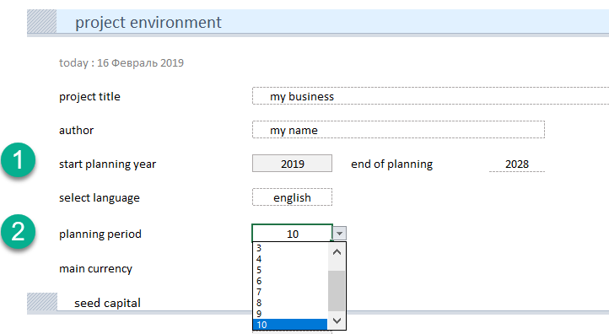
- Create a basic calculation using only the basic business indicators. With the minimum allowed detalization of the source data, set the initial values of income and expenses and market trends.
For this, each section has basic data entry fields:
  - Name of the item or planning object.
  - Cost indicator (sales price or amount of expenses) depending on the selected input form.
  - Quantitative indicator of the planning object being sold or purchased.
  - Starting date of selling prices or amounts of expenses.
- The template will automatically calculate the financing requirement of the business project.
IMPORTANT. Achieve a positive cash flow over the entire planning period.
- Specify the source planning data, achieve values close to the expected result. It is necessary to clarify the periods of growth, to identify the stages of active investments, the expected growth based on these investments.
- Carry out the analysis, evaluate the result.

Build a Financial Model

Project Organization Planning
Before starting financial planning, we strongly recommend that you create a general organizational project implementation plan. This will allow to:
- Get the start of planning year and the planning period.
- Identify key stages (dates) of financial planning.
- Use the plan to control the financial activity stages at the end of the modeling.
Plan Sample
year | 2019 | 2020 | 2021 | 2022 | 2023
stage
stage 1. Investment period 1 | From 03/17 to 12/17
stage 2. Beginning of sales. |  | From 01/18
stage 3. Investment period 2 |  | 09/18 to 12/18
stage 4. Increase in sales volume |  |  | From 01/19

Source Data
Go to the "setup" section and fill in the fields:
- Start planning year (mandatory).
- Planning period, full years (mandatory).
- Primary tax currency (mandatory).
- Own (share) capital (mandatory).
- Beginning cash, the last year result (if available – mandatory).
Additional Tools

Indexing of Results
Financial calculations can generate estimates consisting of a large number of digits. Reading and transferring values of 6–7 characters may be uncomfortable. A tool has been added to the template to reduce the dimensionality of the reports.
In the section "Source Data", go to the subsection "Capacity of Totals".
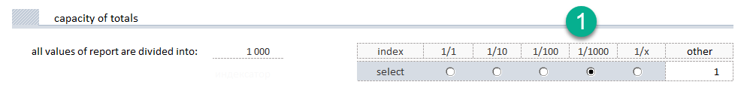
Select the divisor to the right (1). All data in the reports:
- Totals
- Cash flow
- Profit and loss
- Investment performance data
will change the dimensionality according to the selected value.
The tool will divide all values in the report by the selected division index, thereby reducing the size of the values obtained. At the top of the table, information will appear that all data in the table should be taken into account based on the selected index, for example, x 1000.
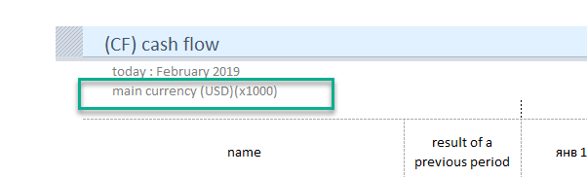

Sales Planning.
The template has two built-in sales planning mechanisms.
- Automated.
- Manual.
"Automated mode"
Determine the product features (name, price, quantity, etc.), and the rules of conduct in the selected planning period. The tool will automatically build a "lifeline" for each product, taking into account the selected rules.
Basic Management Rules
- Sales period management.
- Management of the life period of the product with selected product features.
- Seasonality management.
- Management of the product growth in the first year of life.
Go to the "sales planning" section and fill in the required fields. Compulsory minimum:
- Product name
- Selling price per unit
- The amount of products sold per month
- Sales start date
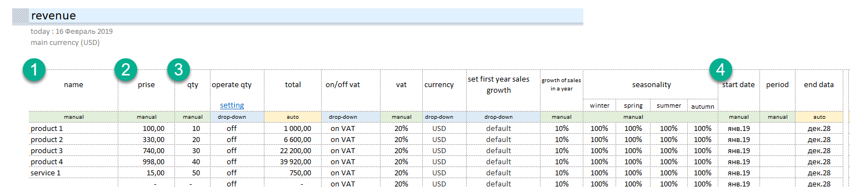
In addition, for projects starting their business activities "from scratch", it is recommended to determine the behavior of sales in the first year of product life (1).
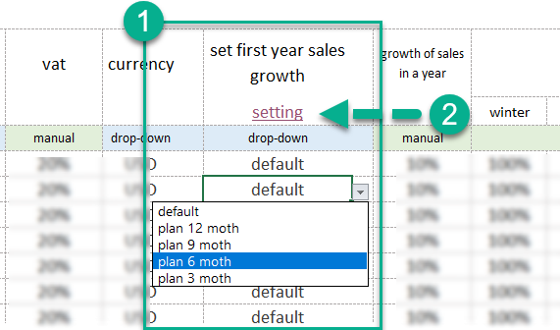
The tool allows to determine the first 12 months of product growth percentage wise. For this purpose, "schemes" are used. Go to setting (2). There are 5 schemes in the template:
- "default". Sales from the first month of sales have nominal volumes.
- "12 months scheme". Sales will grow evenly over the first 12 months, from 10% to 100%.
- "9 months scheme". Sales will grow the first 9 months, from 30% to 100%
- "6 months scheme". Sales will grow the first 6 months, from 20% to 100%
- "3 months scheme". Sales will grow the first 3 months, from 40% to 100%
Schemes may be rebuilt as you see fit.
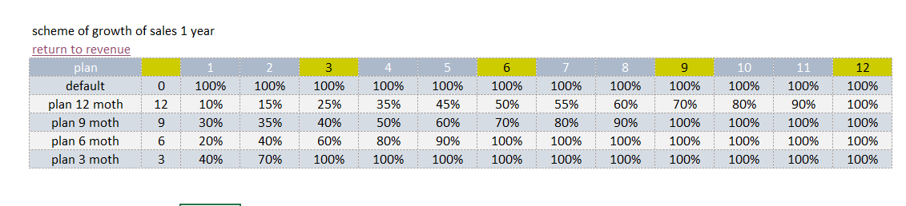
Scheme name and percentages can be changed. In manual mode, determine the growth order for the selected scheme.
Important. If you defined the name earlier and then changed it in the setting, you need to redefine the scheme in the sales section again.

The following may be defined additionally
- Sales growth rate, % per annum
- Seasonality
- Sales period
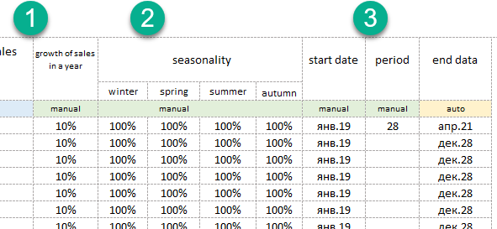

"Manual Mode"
In the "manual mode" you can set the quantity of products sold monthly.
To use this mode, for each position in the "sales planning" section, in the "manage quantity" column, set the "drop-down list" switch to the "on" position.

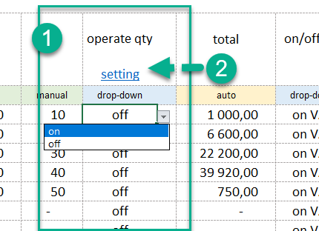

- (1) for the selected position of the sales plan, enable the mode (on|off),
- (2) go to the quantity management section.
IMPORTANT. The manual sales management mode takes precedence over the "automatic mode" settings.

Multicurrency Calculations
The tool allows to calculate the project in ten different currencies. Set the main currency of the calculation and specify the currency of income or expenditure transactions in the currency in which they will be executed.
The main currency for the project calculation is set in the "project setting" section (1)
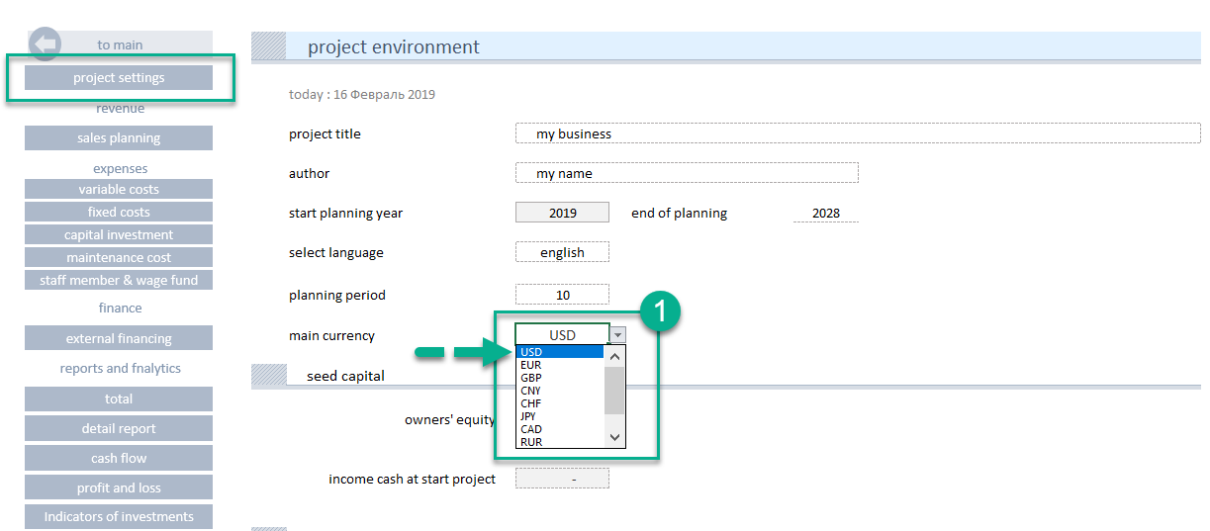
For any position in each section, you can select the currency of the planned operation.
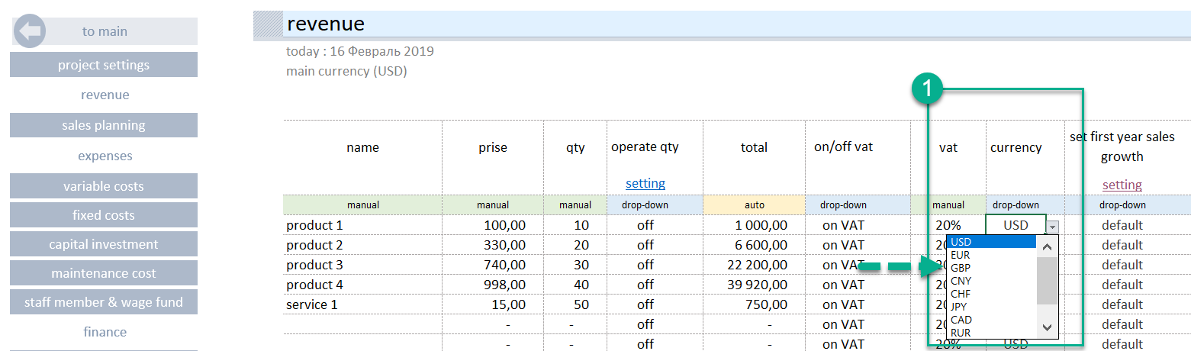

Currency Rate
The template has a separate interface for managing currency rates. In the main navigation, go to the "setting" block in the "exchange rate" section.
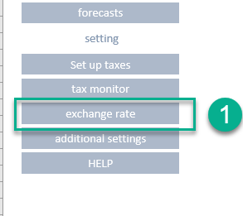
There are 2 blocks in the section:
- Currency calculator
- Exchange-rate determination tool
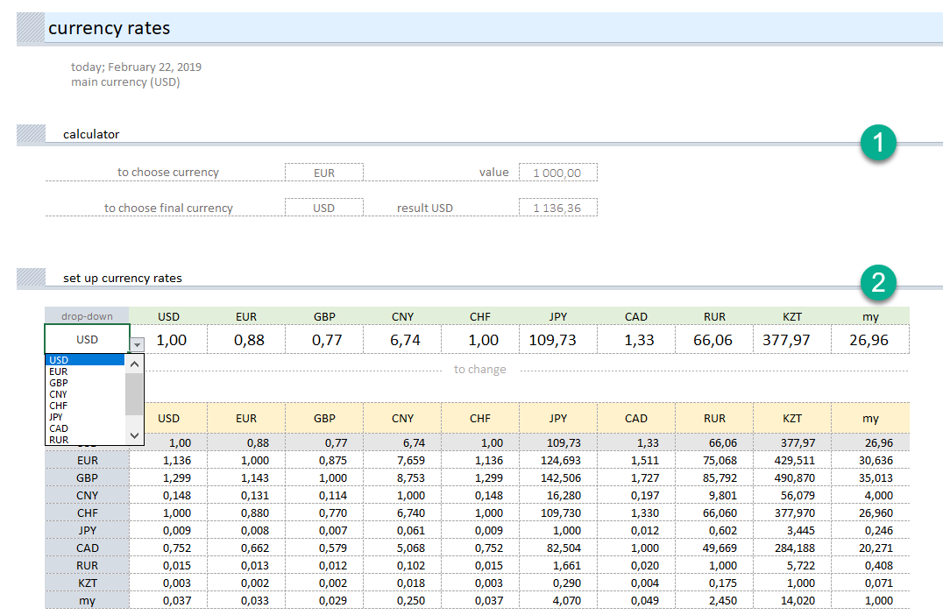
To set the currency rate, in the drop-down list (1) select the currency symbol, against which the exchange rate values will be set.
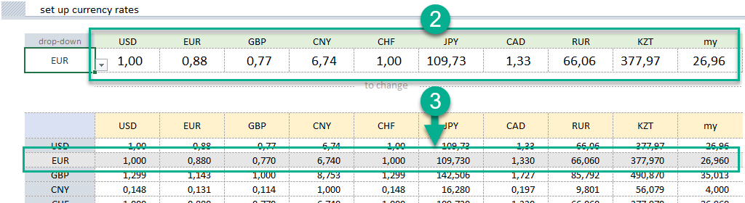
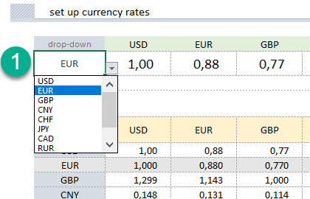

In line (2), change the exchange rate of the currency to be used in the calculations
The selected values will be reflected in the table (3)
Add your own currency
If in the drop-down list of currencies there is no necessary symbol, it can be added. Go to the "additional setting" section.
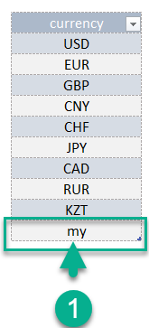
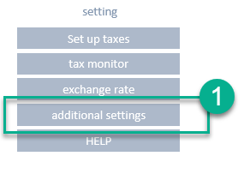
In the list of currencies (1) in the last line, replace the symbol "my" with your own symbol.
Return to the "exchange rate" section, and determine the conversion rates for the newly added currency symbol.

Cost Planning.

Variable Costs
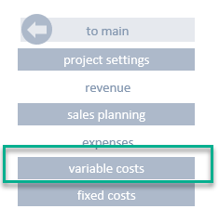
"Variable costs" section
The planning work consists of determining:
- Products (materials), resources, services to be purchased, rental of production space.
- Determining of quantitative indicators, "price", "quantity".
- Determining of the timing, the start date. If the validity period is limited, indicate the validity period of the specified parameters.
Plan the costs associated with production of goods or creation of services. The template allows to plan:
- Variable (indirect) costs associated with production of goods or creation of services.
- Direct costs directly related to the creation of a product or service.
- Determine the size of the purchased material or product in proportion to the sales plan for a particular product or the total sales.
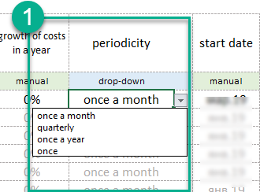
Each purchase can be determined in time with a specified periodicity (1). This allows to set the volume and schedule of purchases as objectively as possible, to manipulate data during modeling.

"Connection with Products" Tool
In order to charge the costs to a particular product or service, in the template in the "dependence of sale" section, you should give a name to the product (1), enable connection with products (2)
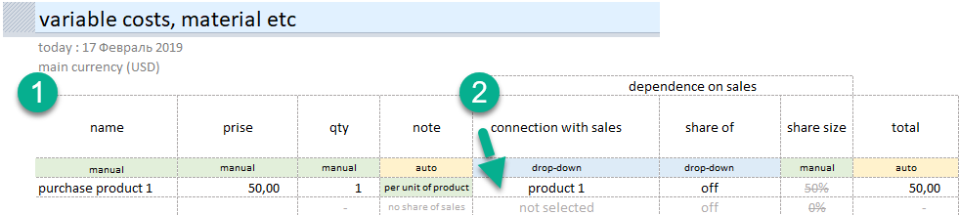
Specify the name of the product being purchased, and establish connection with the product. The tool will take the quantity of goods sold to calculate the purchased goods. In this case, all the goods that were purchased will be sold in the specified planning period.

By manipulating with dates, you can shift the purchase schedule against the sales schedule.
Sales plan product 1 | Purchase plan product 1
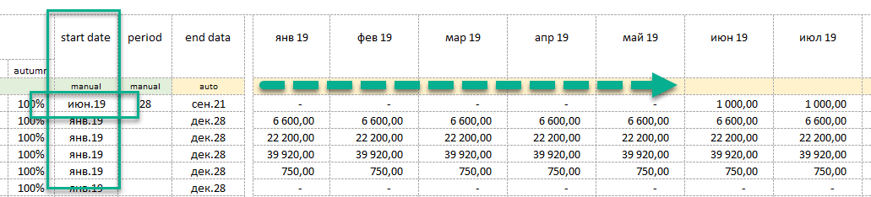
Purchase plan product 1
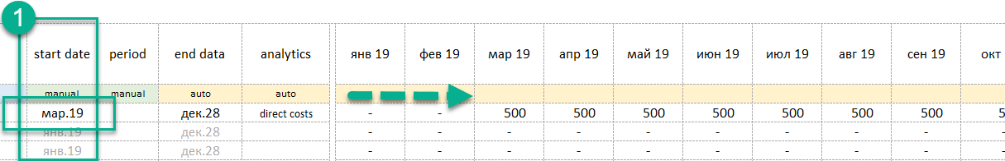

"Product Purchase Volume" Tool
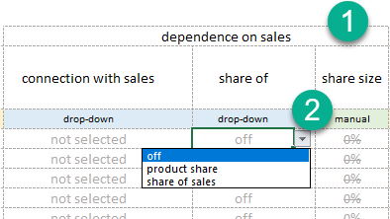
Allows to take into account the purchase volume, expressed as percentage of the product sales volume or total sales. In order to charge the costs to a particular product or service, in the template in the "dependence of sale" section, 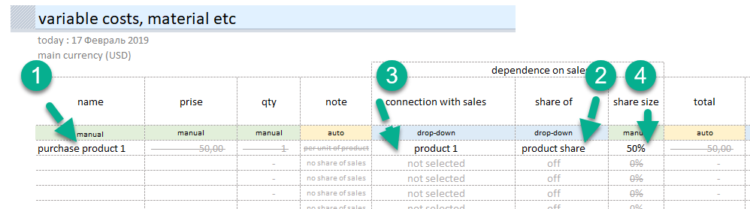
- Specify the name of the product
- Specify the calculation mode
"product share" (1) or "dependence on total sales" (2)
- If at step 2 a connection with the product was established, specify the product (3).
- Determine the product volume percent or total sales percent.
Important. For correct operation of the selection and product and costs connection tool, it is necessary to finally enter the list of products. If, after establishing a connection, you changed the product name, it is necessary to redefine the product again in the selection list (3).

Fixed Costs
The section allows to plan non-manufacturing costs of the project. Rent, utilities, IT, security, banking, exhibitions and more.
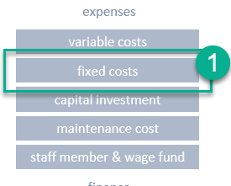
"Fixed Costs" Section
The planning work consists of determining:
- Cost items
- Determining of quantitative indicators, "price", "quantity".
- Analytical signs of procurement for further analysis.
- Determining of the timing, the start date. If the validity period is limited, indicate the validity period of the specified parameters.
Each purchase can be determined in time with a specified periodicity (1). This allows to set the volume and schedule of costs as objectively as possible, to manipulate data during modeling.
Analytics.
The feature of filling in the data in this section is the possibility to define a cost accounting analytics. The working directory contains the following analytics:
- marketing
- lease
- communal
- IT
- banking
- other
- employee benefits
- commission to intermediaries
- storage of products
- other marketing costs
- transport services
- employee training
- low-value equipment
- safety
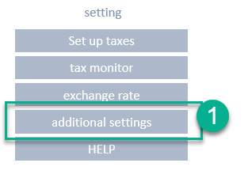
- outsource
You can change this data or add your analytics in "additional setting" (1)
Apart from that, the filling consists of the same actions as in the sales planning.

Capital Investment
The tool allows to determine the purchase of equipment, real estate, land, corporate software, transport. Typically, these costs are associated with capital expenditure of the initial stage of the project, but the tool does not limit the period of investment.
To determine the investment, it is sufficient to specify:
- Name of investment objects (1).
- Indicators "price", "quantity" (2,3).
- Time parameters, purchase date (5).
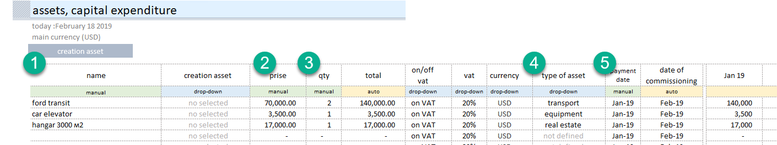
It is necessary, besides the general parameters, to define the analytics – the type of asset (4).
In accordance with the selected analytics, this asset will have its own depreciation term. The depreciation term can be changed in the "additional setting" section.
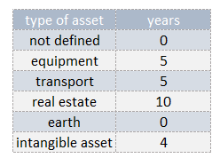

Expenditure Allocation Timing.
During the construction of real property, equipment, creation and integration of corporate software, expenditures should be allocated over time. At the end, all expenditures need to be consolidated within one facility/object being created.
The "creation asset" section is used for this.
You can go to this section from the "capital investment" section.
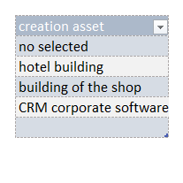
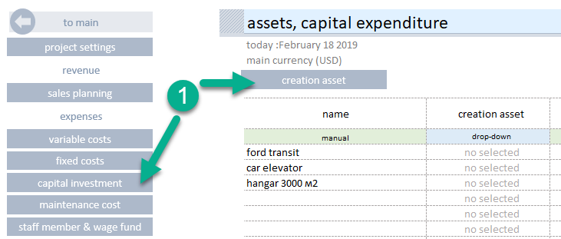
In the "additional setting" section, all created objects of fixed assets should be listed.
In the table, all expenditure items related to the facility/object being created should be successively listed.
- Select an asset in the drop-down list.
- Give the name to the expenditure item.
- Determine the cost.
- Determine the quantity.
- Determine the planned investment date.
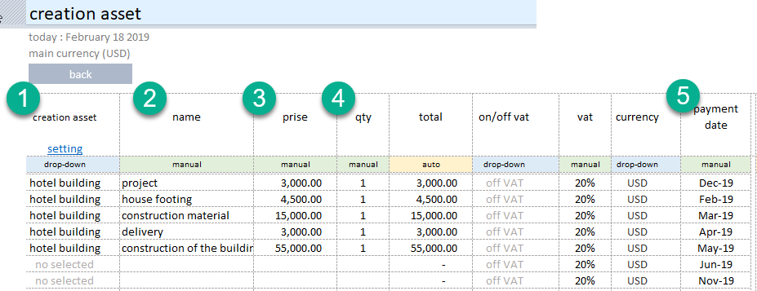
After all planned investments are listed, return to the "Capital investment" section, and define the created object in the free line in the "creation asset" column, in the drop-down box (1).
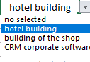
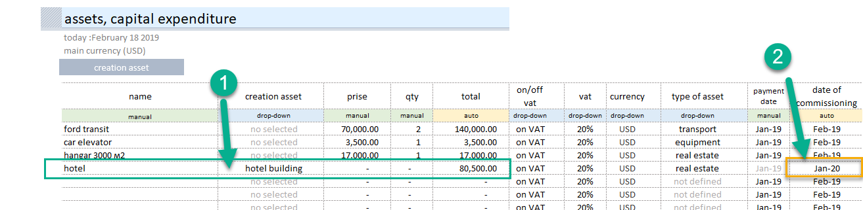

Important. The tool will automatically calculate the date of registration (2) and the start of depreciation.

Maintenance capex
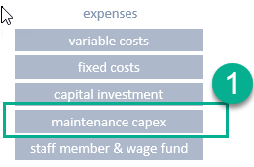
The section allows to plan the costs associated with modernization and asset servicing.
Go to the "maintenance capex" section
To determine the costs of modernization and servicing it is sufficient to specify:
- The item name (1).
- Determine the connection with the asset for which the costs should be allocated (2).
- Indicators "price", "quantity" (3, 4).
- Periodicity of operations (5)
- Time parameters of investments (6).
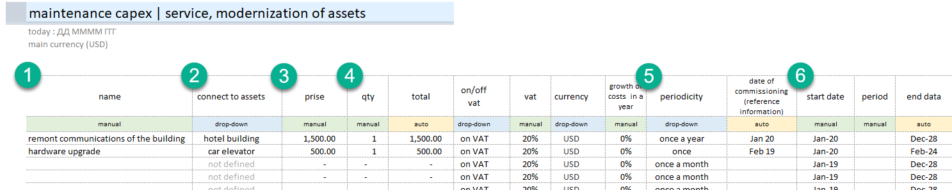
To fill in the data in the section, you can determine the periodicity of expenses (5).
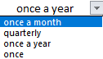
This list is complete. It is not subject to change.

Employee
Section allows to describe the positions and salaries of employees.
Special Features.
- Determine positions (1).
- Salary at the time of the start of planning (2).
- Determine the number of personnel (3).
- Determine the time period for the start of salary payments (4).
- Determine the salary calculation scheme (5).
  - Salary only
  - % + salary
  - only % of the total sales of the project or of the sale of a particular product or service.
- It is advisable to define groups of employees
  - Production,
  - Non-Production.
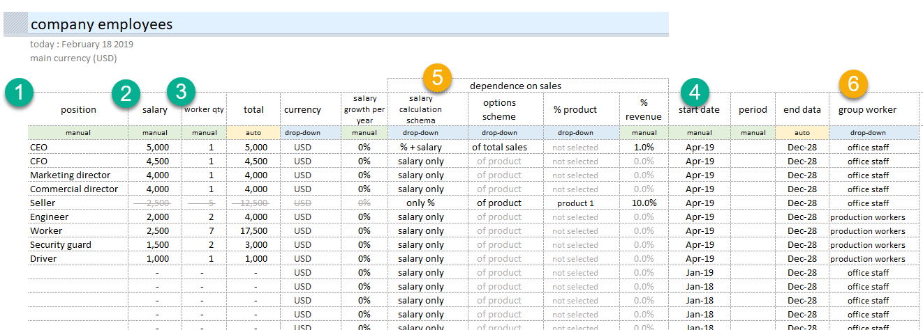

Financing
Calculation of Required Financing.
The tool automatically calculates the need for financing, finds the period in which the money is not enough and selects the amount of necessary financing.
To begin assessing the need for financing, go to the "external financing" section.
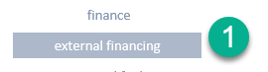
IMPORTANT! The need for financing is a "cash gap". The business project does not have enough money for operations. Such situation should be eliminated.
The need for financing is reflected in the field (1)
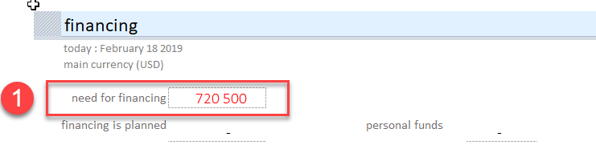
There are three options for solving the problem.
- To attract external returnable financing. A loan or investor's money.
- To attract non-returnable financing. Aids, or other form of non-returnable cash.
- Equity capital, share capital.
Financing is planned in the table in the same section. The following fields are required:
- Name of the loan, or name of the credit institution.
- Amount of loan
- Loan interest rate
- Date of receipt
- Start of return date
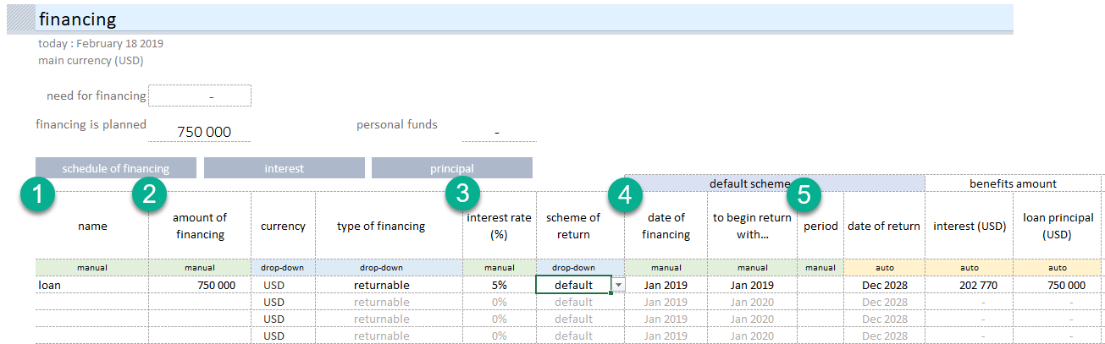

The tool allows to plan aids, grants, shareholders' investments.
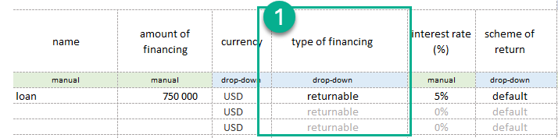
Determine the type of financing (1):
  - "returnable"
  - "non-returnable"
IMPORTANT! For "non-returnable" types of financing, no interest is accrued and no added value refund is accrued.
The template provides for the possibility of non-standard return of borrowed funds. You can separate the loan and interest repayment periods, determine your own repayment scheme for the loan and interest.
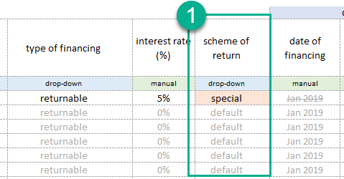 | 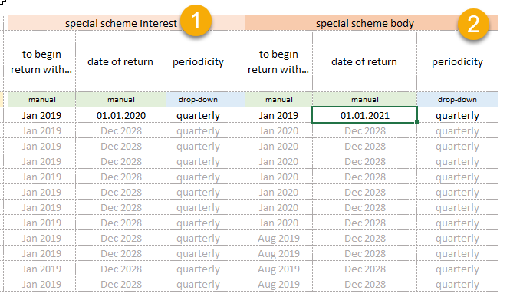

From the "Financing" section you can quickly go to:
- Schedule of financing
- Estimated interest repayment values
- Principal amount of loan
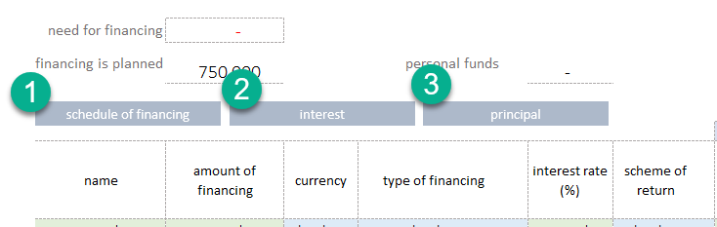

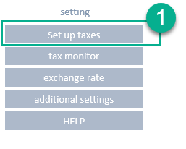
Taxes.
The tool contains a built-in tax arrangement constructor.
By default, tax calculation is turned off. To activate the tax arrangement, go to the "set up taxes" section

The tool allows to model the calculation of:
- Simplified tax system
  - percent (revenue)
  - percent (revenue – costs)
- VAT
- Income tax
  - flat scale
  - progressive scale
- personal income tax
  - flat scale
  - progressive scale
- assignments from wage fund
  - pension fund
  - medicare
  - social security
- property taxes
- land occupation tax
Each mode can be turned on by moving the switch (1) to the "on" position.
Modes are activated by selecting the appropriate "option button"
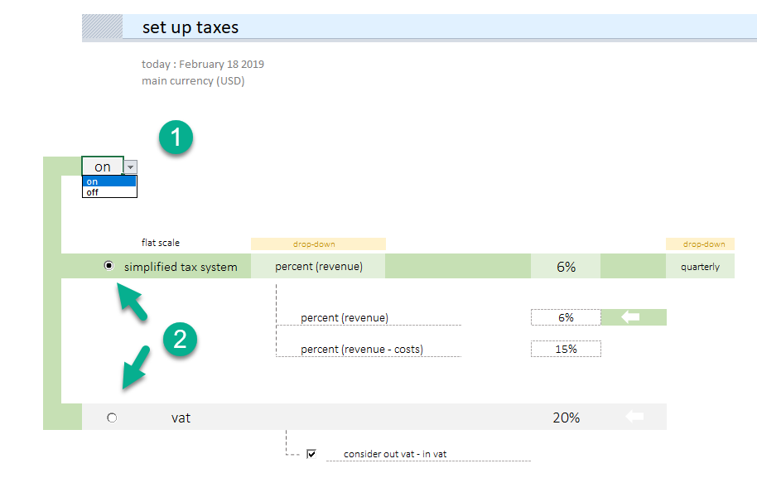

When income tax (1) calculation is activated, it is possible to switch (2) the modes:
- flat scale
- progressive scale

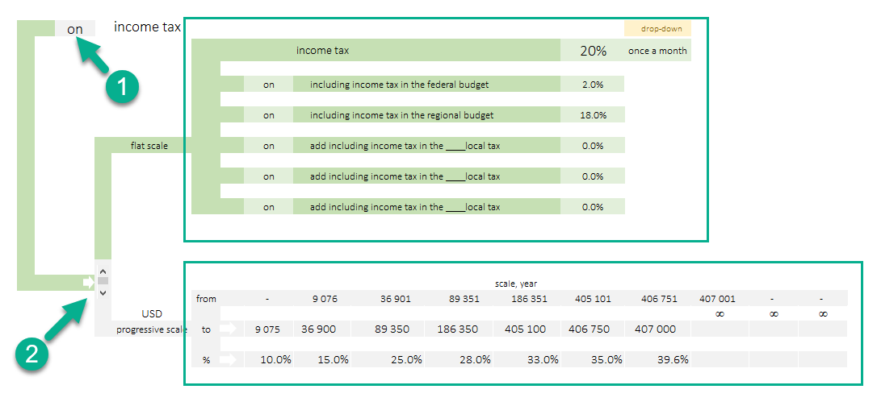
"Flat scale" setting
- Turn the switch (1) to the on "flat scale" position.
- Block (2). Allows to include one of the components of income tax.
- Block (3). Allows to set an income tax component expressed as percentage.
- Block (4). Automatically calculates the amount of income tax.
- Block (5). Allows to set the tax accrual mode:
  - once a month
  - quarterly
  - once a year
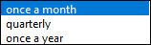
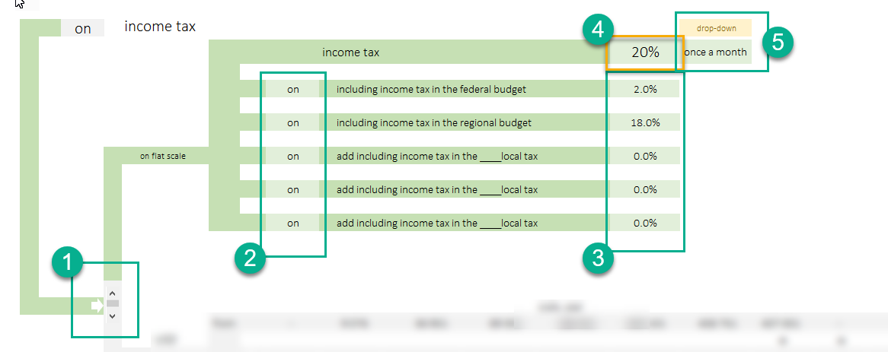

"Progressive Scale" Setting
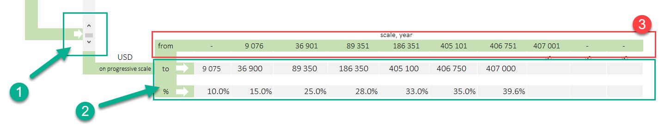
- Turn the switch (1) to the "on progressive scale" position.
- Block (2). Fill out the progressive tax value for the region you plan to do business in.
- Block (3). Automatically calculates the lower limit of the tax bracket.

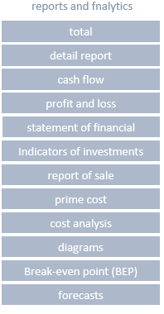
Reports and Analytics
The template automatically generates the following reports:
- Totals
- Extensive totals
- Cash flow (by month)
- Profit and loss (by month)
- Statement of financial position
- Investment performance data
- Future sales analysis
- Prime cost analysis
- General cost analysis
- Diagrams (dynamic)
- Break-even point
- Analysis of forecasts

"Total" Report Form
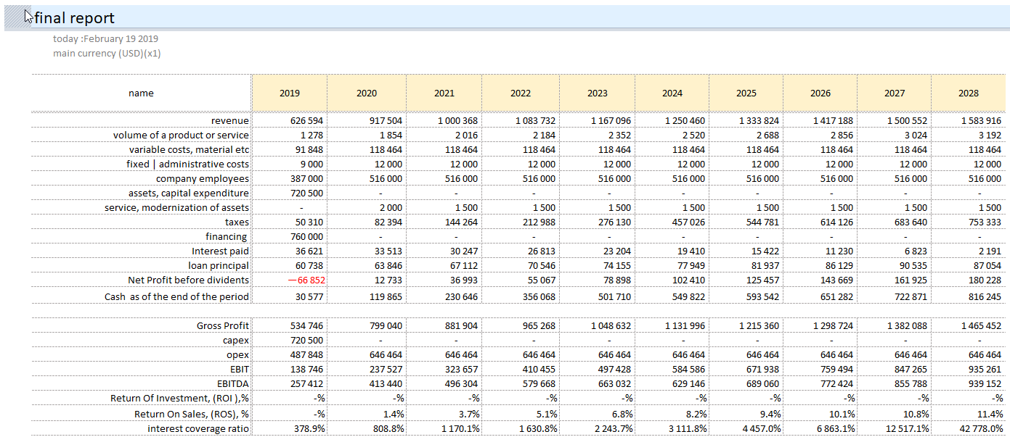

"Detail Report" Form
A full detailed report of the project is generated monthly for the entire planning period.
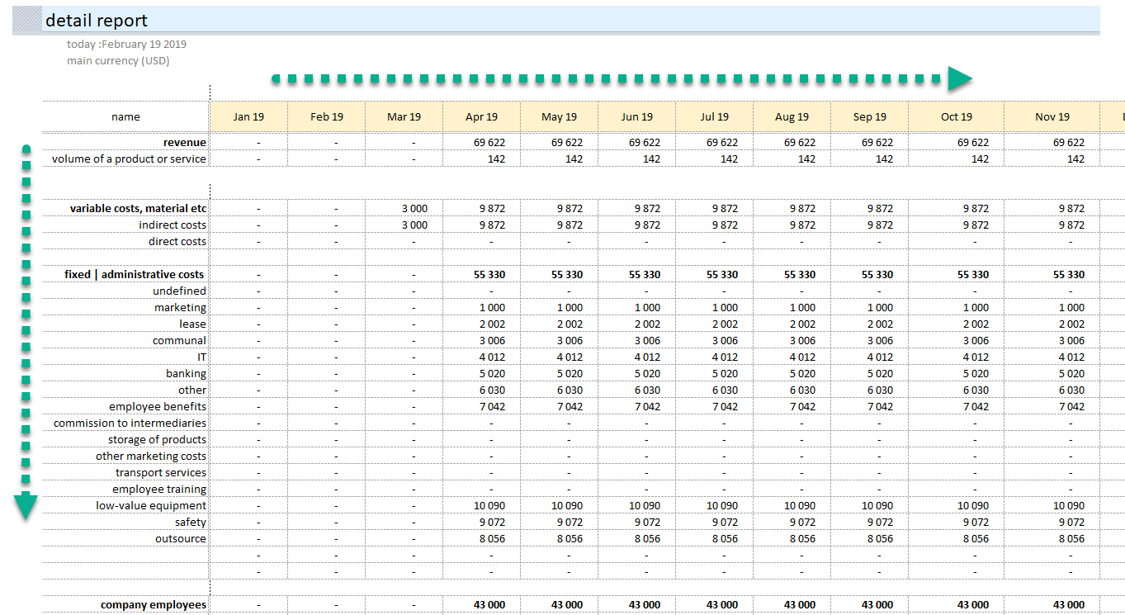
"Cash Flow" Report Form
Cash Flow Report is generated monthly for the entire planning period.

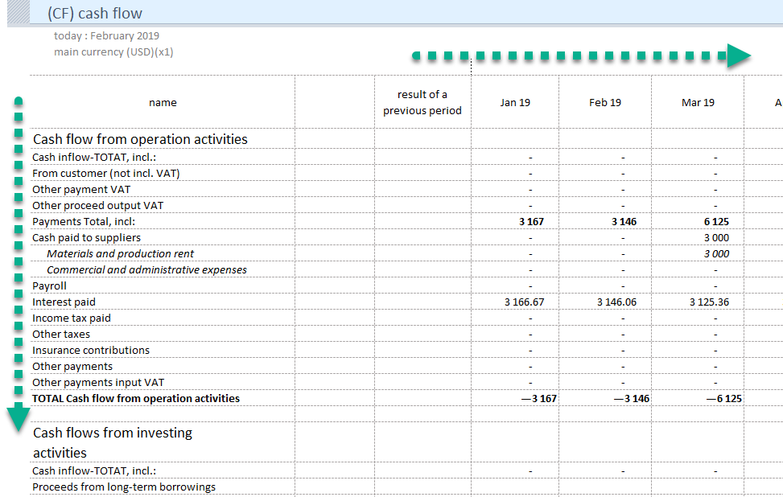

"Profit and Losses" Report Form
"Profit and Losses" Report
A full detailed report of the project is generated monthly for the entire planning period.
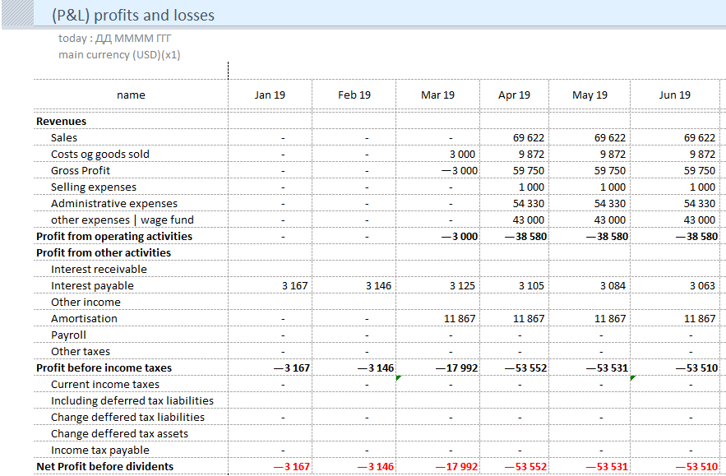

"Investment Indicators" Report
The report calculates the investment performance data of the project.
Investment performance data
- NPV – Net Present Value
- IRR – Internal Rate of Return
- PI – Profitability Index
- PP – Payback Period
- ARR – Accounting Rate of Return
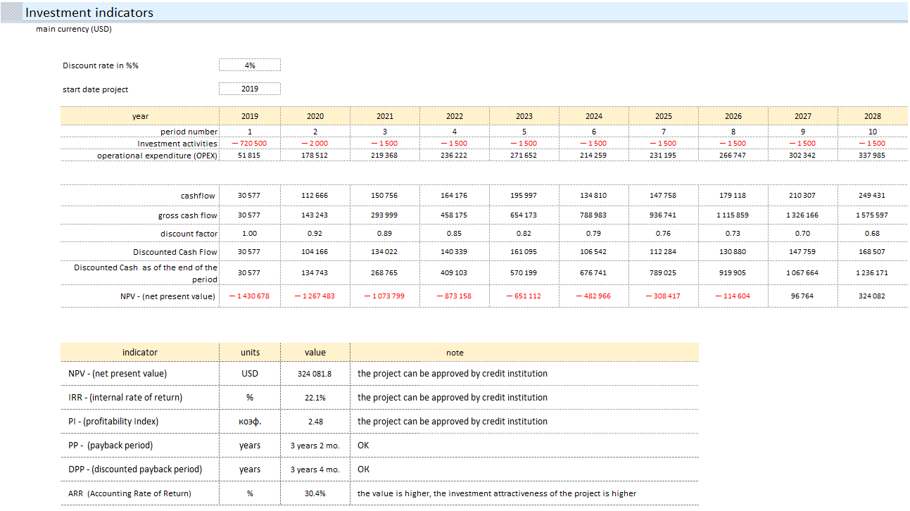

"Report of Sale"
The report and the diagram form the idea the products generating 80% of sales.
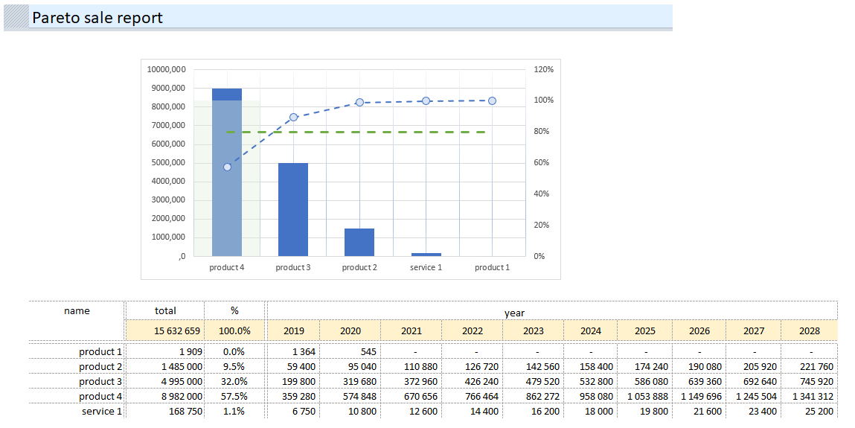
"Prime Cost" Report
The report and the diagram form the idea of how the prime cost of the project will be formed.
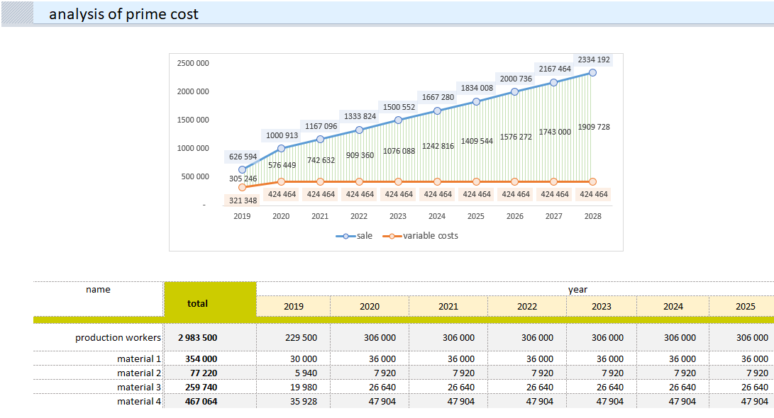

"Cost Analysis" Report
The report and the diagrams provide information for analyzing the structure of production and non-production costs, composition of the salary fund, marketing costs analysis.
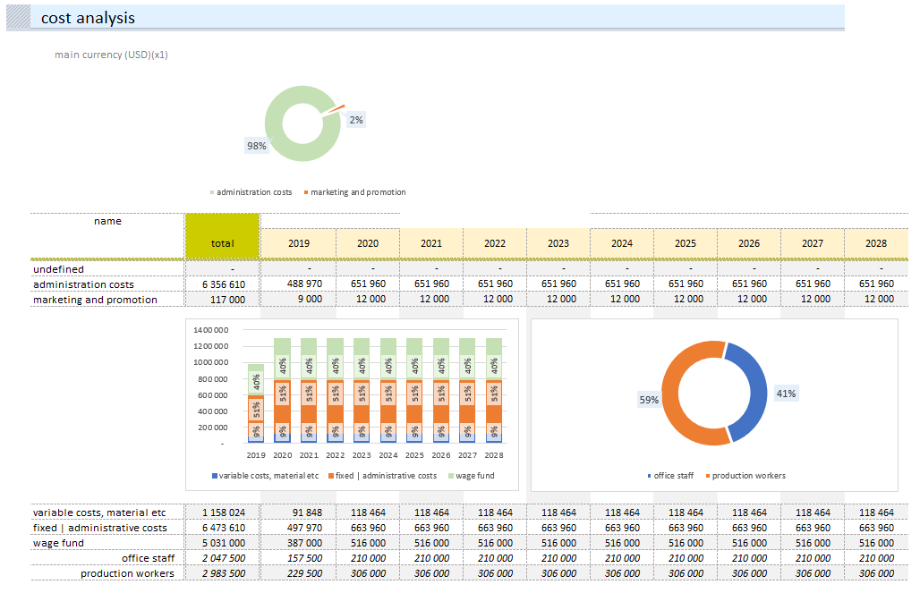

Diagrams.
In the template, there are several types of diagrams for analysis.
All diagrams are dynamic and allow analysis for specified periods.
Structure of Income and Expenses
The "waterfall" diagram allows to trace the chain of income and expenses by year.
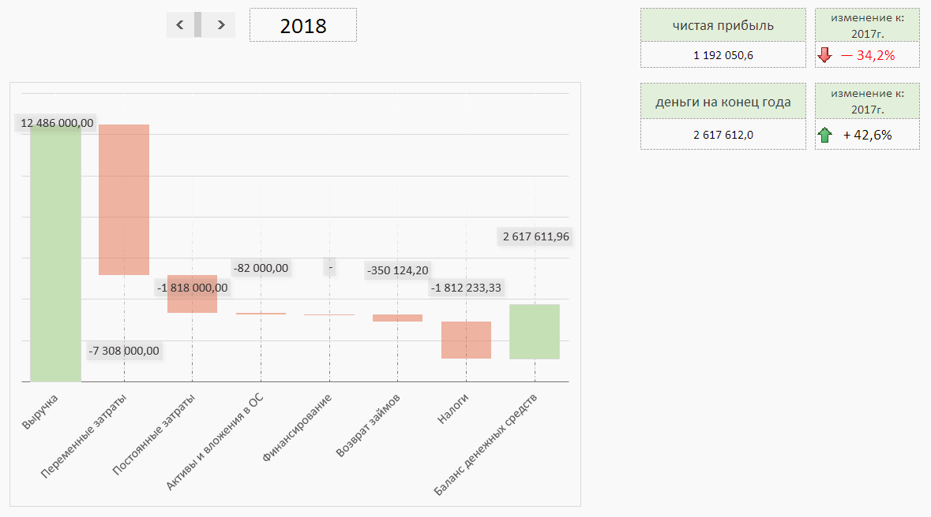
Financing Structure
The diagram allows to trace the structure of project investments by year.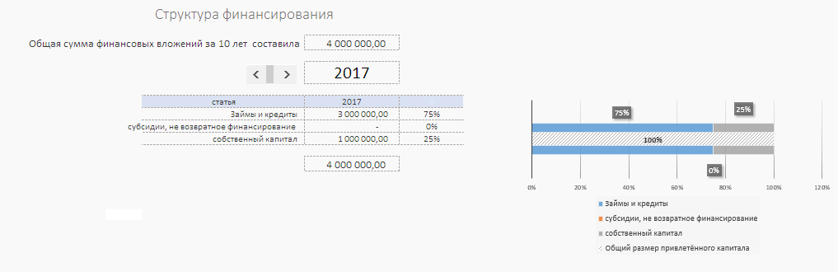
Cost Structure
Two interconnected dynamically formed diagrams:
- Project cost structure
- Prime cost structure within costs
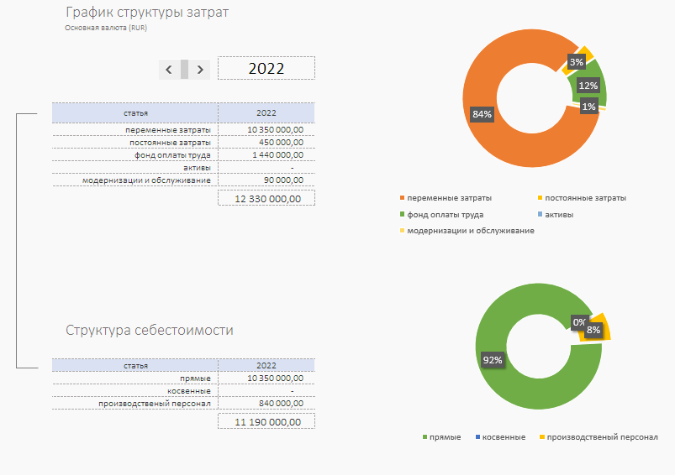
Cash Flow Diagram
The diagram allows to visually identify the missing funds and their amount.
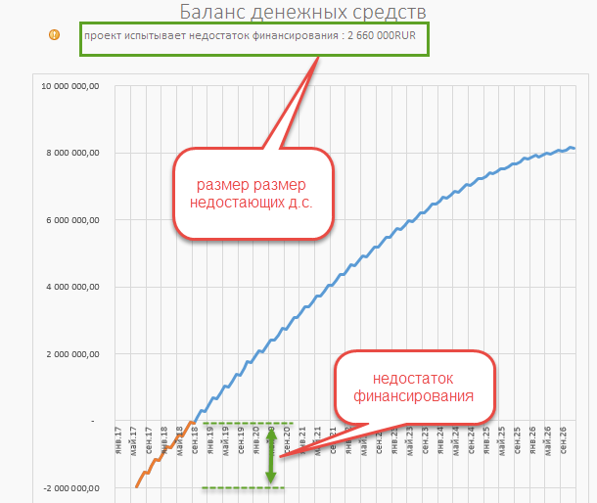

Making Forecasts
The template allows to quickly make forecasts.
Important! Forecasts are made at the end of the main process of financial modeling.
Forecasts are made by increasing or decreasing the volume of sales percentage wise.
To build the expectation bracket, three forecasts for project implementation are mandatory:
• Realistic;
• Optimistic;
• Pessimistic;

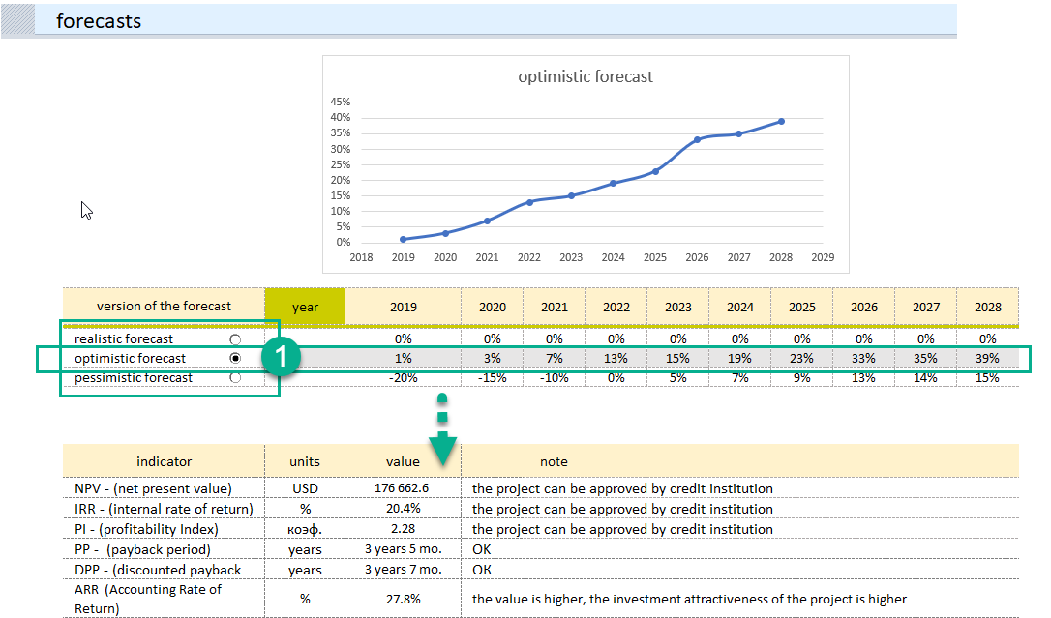
The forecasts created are your vision of how the project may change under favorable external factors, or what will happen to the project if the implementation goes according to an unfavorable scenario.
Realistic (baseline) forecast. This is the current financial model that you generate first. It should reflect real expectations from the implementation of the project time schedule.
Important. Save the current file, make two copies, give them names corresponding to the optimistic and pessimistic variant. Go to making the optimistic forecast.
Optimistic forecast. (1) Open the copy of the optimistic forecast file. What will happen if the situation changes for the better? Understanding of the diversity of facts that can allow to have an optimistic scenario and the potential for positive change.
Save the current optimistic forecast.
Pessimistic forecast. Open the copy of the pessimistic forecast file. Here, it is important to reflect your understanding of the option in which things will go according to the scenario with extremely undesirable consequences.
Recommendations on Using the Tool
THE FIRST ACTION is to create the first financial model that will be considered a realistic forecast and a basis for making optimistic and pessimistic forecasts.
THE SECOND obligatory action is to make sure that the baseline forecast is "ready". Save the basic calculation in three versions with different names reflecting the future type of forecasting (for example, "realistic.xlsx", "optimistic.xlsx", "pessimistic.xlsx") and only then proceed to building forecasts.
THIRD – remember, subsequent changes in these files generate separate branches of the project financial forecast.
IMPORTANT. Change the percentages as you see fit. Do not leave cells empty, this will cause an error.
When creating a pessimistic forecast, pay attention to the appearance of negative sales values on the money flow diagram and to the cash deficit line.
Go to the "external financing" section and eliminate cash shorts using additional financing.

Technical Features of Working with the Tool

Adding lines to the template
By default all tables are designed for 40 records. The necessary formulas are inserted in the tables and the tool is ready to expand the number of lines. You can expand the range with the required number of lines as follows:
Step 1. Select the last line of a table with data.
Step 2. On the right side, grab the lower right corner of the selection with the mouse and stretch to the required number of lines.
See Video

